PORT-A-PIER COmpany

user’s manual
Guide to the Port-A-Pier Iron Horse Trackless Boat Dollies
Summer 2006


TABLE OF CONTENTS

TABLE OF CONTENTS 1
WELCOME TO THE FAMILY 2
WARRANTY INFORMATION 3
IMPORTANT PRECAUTIONS 4
CARE AND MAINTENANCE 5
ORDERING REPLACEMENT PARTS 6
WINCH EXPLODED VIEW 7
FRAME EXPLODED VIEW 8
FREQUENTLY ASKED QUESTIONS 9

WELCOME TO THE FAMILY

Port-A-Pier would like to extend a gracious “Thank You” for purchasing one of our Iron Horse Trackless Boat Dollies. We know that you will be satisfied for many years with the ability of our products to withstand the test of time. Over the last 35 years, we have designed and built products that have proven to meet each of our customer’s waterfront objectives. Furthermore, as a result of your purchase of the Iron Horse Trackless Boat Dolly, you have become a member of a larger tradition that has now stemmed for over thirty-five years—the Port-A-Pier Family.
From the time Port-A-Pier was born in 1970 to the present, its employees have always taken pride in their work to ensure the utmost in quality not only in the products Port-A-Pier produces, but also in meeting and fulfilling each of our client’s objectives. We would like to see these relationships with our customers continue to blossom over the years as they enjoy our products. Thus, being a member of the Port-A-Pier Family assures you the best of both worlds—quality service and the ability to contribute in the revision and development of our company through your comments and suggestions. Our customers are vital to the security and growth of Port-A-Pier; thus ensuring that we’ll be here to serve you for many years to come.
Ladies and Gentlemen, welcome to luxury on the water! More importantly, welcome to the Port-A-Pier Family!!

WARRANTY INFORMATION

LIMITED WARRANTY

PORT-A-PIER Warrants all products against failure for a period of one (1) year when used under reasonable and recommended conditions. This Warranty is extended only to the original owner of the Port-A-Pier product. This warranty is not to be extended past the original owner (i.e. Re-sale).
PORT-A-PIER will provide a five (5) year Warranty on the frame and fabricated materials comprising this product from the date of purchase. This warranty is extended to the original owner as specified above.
PORT-A-PIER and its distributors/dealers reserve the right to make changes in its product lines built and/or sold by them at any time without incurring any obligation to make the same or similar changes on any of its products previously built and/or sold by them.
This Warranty shall be void if the product has been subjected to misuse, damaged by negligence, accident, or altered by other than authorized agents of PORT-A-PIER.

PORT-A-PIER
2212 S. 35th St. • Manitowoc, WI • 54220
Telephone: (920) 682-4908 • Fax: (920) 682-8754 • Internet: www.port-a-pier.com

IMPORTANT PRECAUTIONS

Please read the following PRECAUTIONS before using your new Iron Horse Trackless Boat Dolly:
- It is the responsibility of the owner to ensure that all users are adequately informed of all precautions associated with the use of the Iron Horse Trackless Boat Dolly and other waterfront equipment (i.e. docks, rafts, etc).
- Read all information contained within this manual carefully before using your Iron Horse Trackless Boat Dolly.
- It is recommended that all children wear life-jackets while using the Iron Horse Trackless Boat Dolly unless they are supervised.
- Access for the Iron Horse Trackless Boat Dolly should ALWAYS be kept free of obstacles. Please store all sport and fishing equipment in proper locations after use.
- If a non-PORT-A-PIER product has also been purchased along with an Iron Horse Trackless Boat Dolly, it is recommended that the users of the product follow the procedure specified by the manufacturer. It is also recommended each user is aware of all precautions associated with the product’s use.

CARE AND MAINTENANCE

Port-A-Pier’s Iron Horse Trackless Boat Dolly is virtually maintenance free. However, to ensure longevity and the best possible performance from your trackless dolly system, we recommend the following:
  - Every year, it is recommended that each of the grease fittings be injected with grease. Any standard grease will work fine.
  - You will need to check the air in the tires. If the tire pressure is low, please fill the tires with air before use.
  - Make sure to check that the cables and cable clamps are secure. The cables should not be frayed in any way.

ORDERING REPLACEMENT PARTS

Port-A-Pier, through its thirty-five years in the marine industry, has always been committed to providing complete customer satisfaction. If your Iron Horse Trackless Dolly has been damaged under extreme circumstances and you are in need of replacement parts, we will guarantee you effective assistance from one of our trained service representatives in a professional and timely manner. To aid our service representative in assisting you, please be prepared to give the following information upon contacting Port-A-Pier:
1. The MODEL of your Iron Horse Trackless Dolly.
2. A DESCRIPTION of the item needing to be replaced.
You may contact Port-A-Pier directly by telephone: (920)-682-4908, fax: (920)-682-8754, or E-mail: service@port-a-pier.com

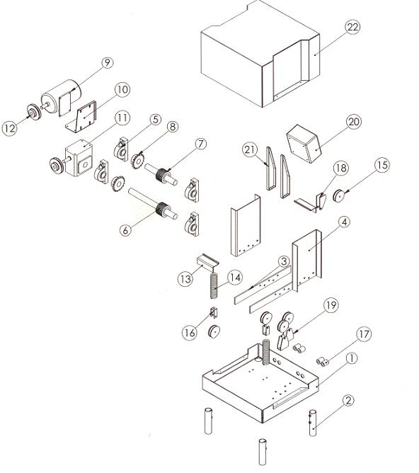
WINCH EXPLODED VIEW
Item#: | Part#: | Unit Qty:
1 | Flat Bar Winch Mount | 1
2 | Setscrew Pipe | 4
3 | Internal Winch Mount | 2
4 | Pillow Black Mount | 2
5 | 2 Inch Pillow Block | 4
6 | Drive Drum Sub-Assembly | 1
7 | Riding Drum Sub-Assembly | 1
8 | Chain Drive Sprocket | 2
9 | 5 HP Motor | 2
10 | Flatbar Motor Mount | 1
11 | Worm Gear Drive | 1
12 | Large Drive Pulley | 2
13 | Center Angle Support | 2
14 | Long Tension Spring | 2
15 | Tension Pulley | 5
16 | Tension Pulley Mount | 2
17 | Coupler | 4
18 | Top Rider Mount | 2
19 | Riding Pulley Mount | 2
20 | Electrical Box | 1
21 | Electrical Box Hanger | 2
22 | Sheet Metal Cover | 1

FRAME EXPLODED VIEW

FREQUENTLY ASKED QUESTIONS
1. (Q). Are navigation lights required to warn boaters of my iron horse while traveling at night?
(A). Warning lights are not required unless your iron horse protrudes into any navigational waterways. If you are concerned whether or not your iron horse protrudes into any navigational waterways, we recommend that you contact your local DNR district representative.

2. (Q). What is the resale value of my iron horse in years to come?
(A).

3. (Q). Can I leave my Iron Horse in year round?
(A). Yes, but you will need to cover your motor with a tarp to protect it from the elements.

4. (Q). Can my boat remain on the Iron Horse all the time or do I need to remove it when I leave for a long period of time?
(A). Your boat never has to leave the iron horse!! If you plan to leave, make sure to cover your lift with a tarp or some other type of covering. We also don’t recommend leaving the iron horse remotes or keys on the boat if you plan to leave for a long period of time.

If you have any questions or comments regarding Port-A-Pier’s Iron Horse, please contact us directly via telephone at (920)-682-4908 or via E-mail to service@port-a-pier.com.
Thank you for choosing Port-A-Pier!!

